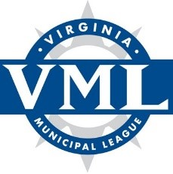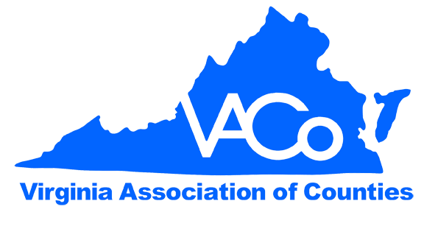
WHY THE VML/VACO APCO STEERING COMMITTEE IS
IMPORTANT TO THE LOCALITIES IN APCO’S SERVICE AREA IN VIRGINIA

Committee Purpose: In 1978, the Virginia Municipal League (VML) and the Virginia Association of Counties (VACo) created a Steering Committee to represent the interests of the localities in the Appalachian Power Company (APCo) service area in connection with the purchase of electric power from APCo. Since that time, the Steering Committee has worked to advance the best interests of localities and other Public Authority Customers (collectively, PAs), negotiating contractual terms with APCo on behalf of the PAs and participating in numerous APCo regulatory cases before the Virginia State Corporation Commission (SCC), all for the purpose of ensuring that the electricity rates charged to the PAs are just and reasonable. Below are highlighted outcomes of the Steering Committee’s work in recent years:

Favorable Electricity Rates | APCo’s Public Authority customers have realized substantial financial savings as a result of the Steering Committee’s specific efforts in both contractual negotiations with APCo and numerous SCC cases involving APCo over the last several years. These highlights are further detailed on the Steering Committee web page and can be summarized as follows:
- During the last two contractual negotiation cycles, the Steering Committee was successful in negotiations with APCo that saved the PAs and, by extension, the taxpayers in APCo’s service area in Virginia more than $17 million.
- In numerous cases, APCo’s revenues from proposed rate increases, depreciation methodology for retirement of a coal plant, cost recovery methodologies for renewable energy investments, and vegetation management would have been significantly higher had it not been for the opposition of the Steering Committee and other rate payer advocacy organizations. In many of these cases, the Steering Committee has played a leading role in forming successful, strategic alliances that have enhanced the Committee’s leverage resulting in $140 million in savings for all ratepayers, including PA customers.

Legal/Technical Expertise and Experience | The Steering Committee retains expert legal and technical assistance to assist the Steering Committee in negotiating rates/contracts with APCo and to oppose APCo’s proposed rate increases in major cases before the SCC. For 48 years, the Steering Committee has negotiated fair and reasonable rates for the PAs and has secured electric service agreements that local governments can enter into with confidence.  As specified in the Financial Benefits Summary, the Steering Committee’s legal team has effectively represented the PAs in multiple cases before the SCC, opposing unreasonable rate increases sought by APCo and APCo’s plans to add expensive, yet unnecessary, generating capacity.
Significant Value through Shared Legal Costs | The Steering Committee acts on behalf of all political subdivisions in the APCo service area, navigating the complex legal and regulatory structures and negotiating favorable rates, terms and conditions of their electrical service. Public Authority entities are invited to share the costs incurred by the Steering Committee on a pro rata basis. Without this joint effort, each entity would be left to negotiate with APCo on its own, retaining counsel and consultants independently at considerably higher cost.
Credibility with the SCC | Over the last several years, counsel for the Steering Committee has continued to build on their excellent reputations with the SCC. On multiple occasions, the Commissioners have commented on the importance of the localities’ having legal counsel in rate cases and related proceedings before the SCC. In addition, Steering Committee counsel has developed strong relationships with the other parties that participate in APCo’s rate cases, which has inured to the benefit of the PAs.

FAQ on Membership and Assessments:
Below are answers to common questions localities and other public authority customers in the APCo service territory have regarding membership and dues assessments for the VML/VACo APCo Steering Committee.
Purpose/Need | The primary work of the Steering Committee is to negotiate contracts with APCo every 3-4 years and to represent the Steering Committee’s interests in key APCo regulatory cases before the SCC. Both the contractual negotiations and case participation involve highly complex and technical subject matter and require substantial time and expertise on the part of counsel. The Steering Committee only participates in SCC cases if they are deemed to have a substantial impact on Public Authority electricity rates or other key utility services.
Method of Assessment | The Steering Committee funds its efforts by voluntary assessments contributed by all of the Public Authority (PA) customers in APCo’s Virginia service territory. Each assessment is calculated to be proportionate to the kWh usage of each member (which includes counties, cities, towns, school divisions, and public authorities of all types). APCo furnishes the Steering Committee with the amount of usage and annual billings for each entity so that assessments can be fairly apportioned. The financial benefit to PA customers has always been substantially larger than the assessment paid by each locality.
Administration of Committee | The Steering Committee By-laws Steering Committee By Laws provide information related to the administration of the Steering Committee. VML serves as the fiscal agent for all members, including VACo and other Public Authority customers that are not otherwise affiliated with VML. As the fiscal agent, VML is directed to send invoices each political subdivision, collect and maintain the funds received, provide administrative support for the Steering Committee to advance its core mission, and make disbursements to pay Steering Committee expenses for counsel, consultants and other services.
Participation and Designated Contact | Each member agency or locality should designate one contact person to serve as the conduit for information between VML and the member. An organizational administrator, finance director, or facilities manager are commonly appointed to this role. Most communications are by email, so it is important to provide an up-to-date email address for your organization’s designee.
Questions | Committee Activities: Jeffrey Shawver  VML/VACo APCo Steering Committee Chair  Email: jshawver@rspc.info or 540-853-6306  Invoice: Sandy Harrington  VML Secretary/Treasurer  e-mail: sharrington@vml.org or 804-823-8524

